VISVESVARAYA TECHNOLOGICAL UNIVERSITY

**“JnanaSangama”, Belgaum -590014, Karnataka.**



# LAB REPORT

**On**

# DATA STRUCTURES (23CS3PCDST)

**Submitted by**

**SUMIT KUMAR CHAUDHARY**

**(1BM22CS296)**

**in partial fulfillment for the award of the degree of BACHELOR OF ENGINEERING**

**in**

# COMPUTER SCIENCE AND ENGINEERING



**B.M.S. COLLEGE OF ENGINEERING**

**(Autonomous Institution under VTU) BENGALURU-560019**

**Dec 2023- March 2024**

**B. M. S. College of Engineering,**

**Bull Temple Road, Bangalore 560019**

**(Affiliated To Visvesvaraya Technological University, Belgaum) Department of Computer Science and Engineering**



This is to certify that the Lab work entitled **“DATA STRUCTURES”** carried out by SUMIT KUMAR CHAUDHARY **(1BM22CS296)**, who is bonafide student of **B. M. S. College of Engineering**. It is in partial fulfillment for the award of **Bachelor of Engineering in Computer Science and Engineering** of the Visvesvaraya Technological University, Belgaum during the year 2023-

24. The Lab report has been approved as it satisfies the academic requirements in respect of Data structures Lab - **(23CS3PCDST)** work prescribed for the said degree.

**Prof. Lakshmi Neelima Dr. Jyothi S Nayak**

Assistant Professor Professor and Head

Department of CSE Department of CSE

BMSCE, Bengaluru BMSCE, Bengaluru

**Index Sheet**

|  |  |  |
| --- | --- | --- |
| **Sl.**  **No.** | **Experiment Title** | **Page No.** |
| 1 | Stack Implementation using Arrays | 4-5 |
| 2 | Infix to Postfix Conversion | 6-7 |
| 3 | Queue implementation using Arrays | 8-14 |
| 4 | Creation and Insertion in Single Linked list | 15-18 |
| 5 | Creation and Deletion in Single Linked List | 19-23 |
| 6 | Sort, Reverse and Concatenation using Single Linked List  Stack and Queue implementation using Single Linked List  Leetcode Problem-1: Parentheses Checker | 24-36 |
| 7 | Implementation of Doubly Linked List with primitive Operations  Leetcode Problem-2: Delete middle node of Linked List | 36-42 |
| 8 | Binary Search Tree- Creation, Traversal using Infix, Postfix and Preorder  Leetcode Problem-4: Delete node in BST  Leetcode Problem-5: Find bottom left Tree Value | 43-49 |
| 9 | Graph traversing using BFS method and DFS method | 50-55 |
| 10 | Hash Table, Resolving with Linear Probing | 55-58 |

**Course outcomes:**

|  |  |
| --- | --- |
| CO1 | Apply the concept of linear and nonlinear data structures. |
| CO2 | Analyze data structure operations for a given problem |
| CO3 | Design and develop solutions using the operations of linear and nonlinear data structure for a given specification. |
| CO4 | Conduct practical experiments for demonstrating the operations of different data structures. |

**LAB PROGRAM-1**

**Write a program to simulate the working of stack using an array with the following:**

1. **Push**
2. **Pop**

**c) Display**

**The program should print appropriate messages for stack overflow, stack underflow.**

#include <stdio.h>

#include <stdlib.h>

#define STACK_SIZE 5

void push(int st[], int *top, int item) {

if (*top == STACK_SIZE - 1) {

printf("Stack overflow\n");

} else {

(*top)++;

st[*top] = item;

}

}

int pop(int st[], int *top) {

int deletedItem;

if (*top == -1) {

printf("Stack underflow\n");

return -1;

} else {

deletedItem = st[*top];

(*top)--;

return deletedItem;

}

}

void display(int st[], int *top) {

int i;

if (*top == -1) {

printf("Stack is empty\n");

} else {

printf("Stack elements: ");

for (i = 0; i <= *top; i++) {

printf("%d\t", st[i]);

}

printf("\n");

}

}

int main() {

int st[STACK_SIZE];

int top = -1, c, item;

while (1) {

printf("\n1. Push\n2. Pop\n3. Display\n4. Exit\n");

printf("Enter your choice: ");

scanf("%d", &c);

switch (c) {

case 1:

printf("Enter an item: ");

scanf("%d", &item);

push(st, &top, item);

break;

case 2:

item = pop(st, &top);

if (item != -1)

printf("%d item was deleted\n", item);

break;

case 3:

display(st, &top);

break;

case 4:

exit(0);

default:

printf("Invalid choice!!!\n");

}

}

return 0;

}

**Output:**

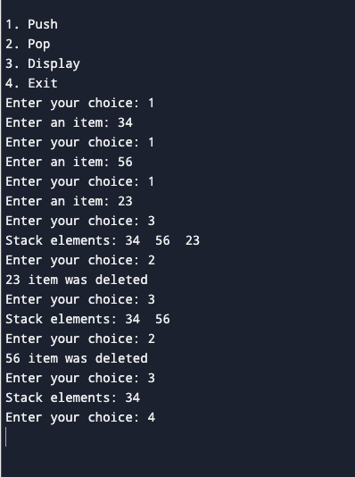

**LAB PROGRAM-2**

**WAP to convert a given valid parenthesized infix arithmetic expression to postfix expression. The expression consists of single character operands and the binary operators + (plus), - (minus), * (multiply) and / (divide).**

#include <stdio.h>

#include <stdlib.h>

#include <string.h>

#define MAX_SIZE 100

typedef struct {

char items[MAX_SIZE];

int top;

} Stack;

void initialize(Stack *s) {

s->top = -1;

}

int isEmpty(Stack *s) {

return s->top == -1;

}

int isFull(Stack *s) {

return s->top == MAX_SIZE - 1;

}

void push(Stack *s, char c) {

if (!isFull(s)) {

s->items[++(s->top)] = c;

}

}

char pop(Stack *s) {

if (!isEmpty(s)) {

return s->items[(s->top)--];

}

return '\0';

}

char peek(Stack *s) {

if (!isEmpty(s)) {

return s->items[s->top];

}

return '\0';

}

int isOperator(char c) {

return (c == '+' || c == '-' || c == '*' || c == '/');

}

int precedence(char op) {

if (op == '+' || op == '-')

return 1;

if (op == '*' || op == '/')

return 2;

return 0;

}

void infixToPostfix(char *infix, char *postfix) {

Stack operatorStack;

initialize(&operatorStack);

int i, j = 0;

for (i = 0; infix[i]; i++) {

char token = infix[i];

if (token == '(') {

push(&operatorStack, token);

} else if (token == ')') {

while (!isEmpty(&operatorStack) && peek(&operatorStack) != '(') {

postfix[j++] = pop(&operatorStack);

}

pop(&operatorStack); // Discard '('

} else if (isOperator(token)) {

while (!isEmpty(&operatorStack) && precedence(peek(&operatorStack)) >= precedence(token)) {

postfix[j++] = pop(&operatorStack);

}

push(&operatorStack, token);

} else { // Operand

postfix[j++] = token;

}

}

while (!isEmpty(&operatorStack)) {

postfix[j++] = pop(&operatorStack);

}

postfix[j] = '\0';

}

int main() {

char infix[MAX_SIZE], postfix[MAX_SIZE];

printf("Enter a valid parenthesized infix arithmetic expression: ");

fgets(infix, sizeof(infix), stdin);

infix[strcspn(infix, "\n")] = '\0'; // Remove trailing newline

infixToPostfix(infix, postfix);

printf("Postfix expression: %s\n", postfix);

return 0; }

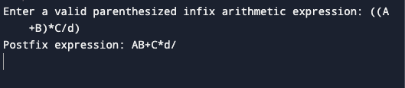

**LAB PROGRAM-3a)**

**WAP to simulate the working of a queue of integers using an array. Provide the following operations: Insert, Delete, Display The program should print appropriate messages for queue empty and queue overflow conditions**

#include <stdio.h>

#include <stdlib.h>

#define MAX_SIZE 5

int queue[MAX_SIZE];

int front = -1, rear = -1;

void insert(int value) {

if (rear == MAX_SIZE - 1) {

printf("Queue overflow\n");

return;

}

if (front == -1)

front = 0;

rear++;

queue[rear] = value;

}

int delete() {

if (front == -1 || front > rear) {

printf("Queue underflow\n");

return -1; // Return some default value to indicate failure

}

int deletedItem = queue[front];

front++;

return deletedItem;

}

void display() {

if (front == -1 || front > rear) {

printf("Queue is empty\n");

return;

}

printf("Queue elements: ");

for (int i = front; i <= rear; i++) {

printf("%d ", queue[i]);

}

printf("\n");

}

int main() {

int choice, value;

while (1) {

printf("\n1. Insert\n2. Delete\n3. Display\n4. Exit\n");

printf("Enter your choice: ");

scanf("%d", &choice);

switch (choice) {

case 1:

printf("Enter the value to insert: ");

scanf("%d", &value);

insert(value);

break;

case 2:

printf("Deleted item: %d\n", delete());

break;

case 3:

display();

break;

case 4:

exit(0);

default:

printf("Invalid choice\n");

}

}

return 0;

}

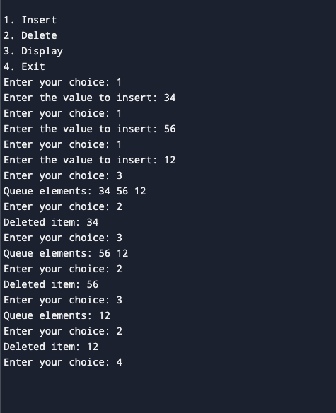

**LAB PROGRAM-3b)**

**WAP to simulate the working of a circular queue of integers using an array. Provide the following operations: Insert, Delete & Display The program should print appropriate messages for queue empty and queue overflow conditions**

#include <stdio.h>

#include <stdlib.h>

#define MAX_SIZE 5

int queue[MAX_SIZE];

int front = -1, rear = -1;

void insert(int value) {

if ((front == 0 && rear == MAX_SIZE - 1) || (rear == (front - 1) % (MAX_SIZE - 1))) {

printf("Queue overflow\n");

return;

} else if (front == -1) {

front = rear = 0;

queue[rear] = value;

} else if (rear == MAX_SIZE - 1 && front != 0) {

rear = 0;

queue[rear] = value;

} else {

rear++;

queue[rear] = value;

}

}

int delete() {

if (front == -1) {

printf("Queue underflow\n");

return -1; // Return some default value to indicate failure

}

int deletedItem = queue[front];

if (front == rear) {

front = rear = -1;

} else if (front == MAX_SIZE - 1) {

front = 0;

} else {

front++;

}

return deletedItem;

}

void display() {

if (front == -1) {

printf("Queue is empty\n");

return;

}

printf("Queue elements: ");

if (rear >= front) {

for (int i = front; i <= rear; i++) {

printf("%d ", queue[i]);

}

} else {

for (int i = front; i < MAX_SIZE; i++) {

printf("%d ", queue[i]);

}

for (int i = 0; i <= rear; i++) {

printf("%d ", queue[i]);

}

}

printf("\n");

}

int main() {

int choice, value;

while (1) {

printf("\n1. Insert\n2. Delete\n3. Display\n4. Exit\n");

printf("Enter your choice: ");

scanf("%d", &choice);

switch (choice) {

case 1:

printf("Enter the value to insert: ");

scanf("%d", &value);

insert(value);

break;

case 2:

printf("Deleted item: %d\n", delete());

break;

case 3:

display();

break;

case 4:

exit(0);

default:

printf("Invalid choice\n");

}

}

return 0;

}

**OUTPUT:**

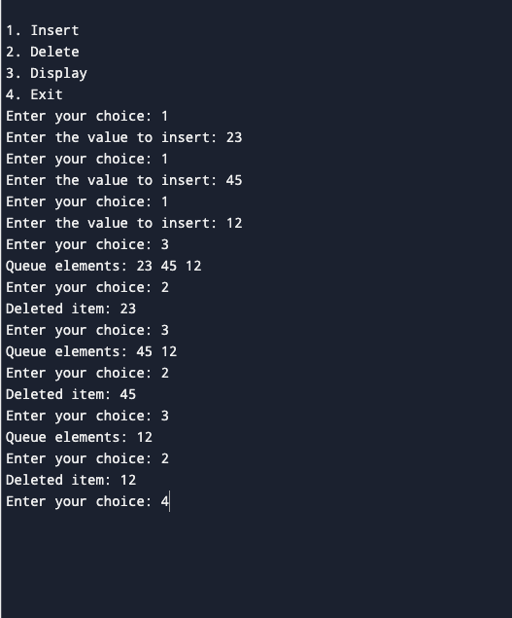

**LAB PROGRAM-4**

**WAP to Implement Singly Linked List with following operations:**

**a) Create a linked list.**

**b) Insertion of a node at first position, at any position and at end of list.**

**Display the contents of the linked list.**

#include <stdio.h>

#include <stdlib.h>

// Node structure

struct Node {

int data;

struct Node* next;

};

// Function to create a new node

struct Node* createNode(int data) {

struct Node* newNode = (struct Node*)malloc(sizeof(struct Node));

if (newNode == NULL) {

printf("Memory allocation failed\n");

exit(1);

}

newNode->data = data;

newNode->next = NULL;

return newNode;

}

// Function to display the linked list

void display(struct Node* head) {

if (head == NULL) {

printf("List is empty\n");

return;

}

struct Node* current = head;

while (current != NULL) {

printf("%d -> ", current->data);

current = current->next;

}

printf("NULL\n");

}

// Function to insert a node at the beginning of the list

struct Node* insertAtBeginning(struct Node* head, int data) {

struct Node* newNode = createNode(data);

newNode->next = head;

return newNode;

}

// Function to insert a node at any position in the list

void insertAtPosition(struct Node* head, int data, int position) {

if (position < 1) {

printf("Invalid position\n");

return;

}

struct Node* newNode = createNode(data);

struct Node* current = head;

for (int i = 1; i < position - 1 && current != NULL; i++) {

current = current->next;

}

if (current == NULL) {

printf("Position out of range\n");

return;

}

newNode->next = current->next;

current->next = newNode;

}

// Function to insert a node at the end of the list

void insertAtEnd(struct Node* head, int data) {

struct Node* newNode = createNode(data);

if (head == NULL) {

head = newNode;

return;

}

struct Node* current = head;

while (current->next != NULL) {

current = current->next;

}

current->next = newNode;

}

int main() {

struct Node* head = NULL;

int choice, data, position;

while (1) {

printf("\n1. Insert at beginning\n2. Insert at position\n3. Insert at end\n4. Display\n5. Exit\n");

printf("Enter your choice: ");

scanf("%d", &choice);

switch (choice) {

case 1:

printf("Enter the data to insert: ");

scanf("%d", &data);

head = insertAtBeginning(head, data);

break;

case 2:

printf("Enter the data to insert: ");

scanf("%d", &data);

printf("Enter the position to insert: ");

scanf("%d", &position);

insertAtPosition(head, data, position);

break;

case 3:

printf("Enter the data to insert: ");

scanf("%d", &data);

insertAtEnd(head, data);

break;

case 4:

display(head);

break;

case 5:

exit(0);

default:

printf("Invalid choice\n");

}

}

return 0;

}

**OUTPUT:**

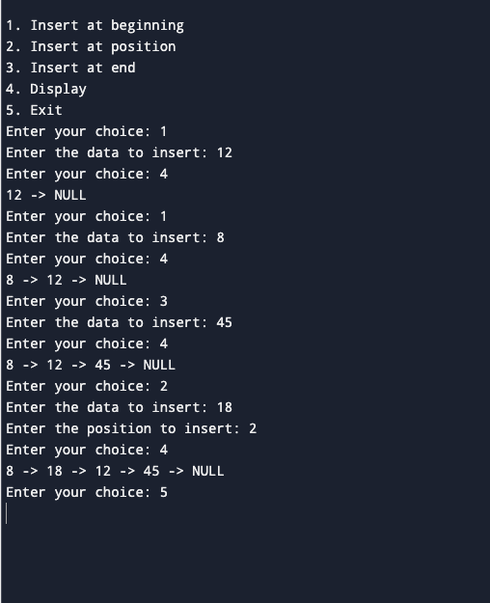

**LAB PROGRAM-5**

**WAP to Implement Singly Linked List with following operations :**

**a) Create a linked list.**

**b) Deletion of first element, specified element and last element in the list.**

**c) Display the contents of the linked list.**

#include <stdio.h>

#include <stdlib.h>

struct node {

int data;

struct node* next;

};

struct node *create_list() {

struct node *head = NULL;

struct node *temp, *new_node;

int num;

char ch;

do {

printf("Enter data: ");

scanf("%d", &num);

new_node = (struct node *)malloc(sizeof(struct node));

new_node->data = num;

new_node->next = NULL;

if (head == NULL) {

head = new_node;

temp = head;

} else {

temp->next = new_node;

temp = new_node;

}

printf("Do you want to add another node? (y/n): ");

scanf(" %c", &ch);

} while(ch == 'y' || ch == 'Y');

return head;

}

struct node *delete_beg(struct node *head){

struct node *temp;

temp=head;

head=head->next;

free(temp);

return head;

}

struct node *delete_end(struct node *head){

struct node *temp, *preptr;

preptr=temp=head;

while(temp->next!=NULL){

preptr=temp;

temp=temp->next;

}

if(temp==head){

head=NULL;

}

else{

preptr->next=NULL;

}

free(temp);

return head;

}

struct node *deleteafter_pos(struct node *head){

struct node *preptr,*temp;

int value;

printf("Enter the value after which you want to delete: ");

scanf("%d",&value);

temp=head;

preptr=temp;

while(preptr->data!=value){

preptr=temp;

temp=temp->next;

}

preptr->next=temp->next;

free(temp);

return head;

}

struct node *deletenode(struct node *head){

struct node *preptr,*temp;

int value;

printf("Enter the value you want to delete: ");

scanf("%d",&value);

temp=head;

if(temp->data==value){

head=delete_beg(head);

return head;

}

else{

while(temp->data!=value){

preptr=temp;

temp=temp->next;

}

preptr->next=temp->next;

free(temp);

return head;

}

}

void display(struct node *head){

if(head == NULL){

printf("List is empty.\n");

return;

}

struct node *temp = head;

while(temp != NULL){

printf("%d ", temp->data);

temp = temp->next;

}

printf("\n");

}

int main() {

struct node *head = NULL;

int choice;

printf("Create Linked List:\n");

head = create_list();

do {

printf("\n1. Delete First\n");

printf("2. Delete Last\n");

printf("3. Delete After Position\n");

printf("4. Delete Node\n");

printf("5. Display\n");

printf("0. Exit\n");

printf("Enter your choice: ");

scanf("%d", &choice);

switch (choice) {

case 1:

head = delete_beg(head);

printf("Node deleted from beginning.\n");

break;

case 2:

head = delete_end(head);

printf("Node deleted from end.\n");

break;

case 3:

head = deleteafter_pos(head);

printf("Node deleted after given position.\n");

break;

case 4:

head = deletenode(head);

printf("Node deleted.\n");

break;

case 5:

printf("Linked List: ");

display(head);

break;

case 0:

printf("Exiting...\n");

break;

default:

printf("Invalid choice. Please try again.\n");

break;

}

} while (choice != 0);

return 0;

}

**OUTPUT:**

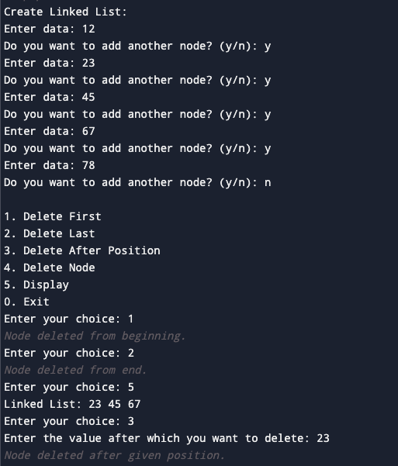

**LAB PROGRAM-6a):**

**WAP to Implement Single Link List with following operations: Sort the linked list, Reverse the linked list, Concatenation of two linked lists.**

#include <stdio.h>

#include <stdlib.h>

struct Node {

int data;

struct Node* next;

};

typedef struct Node Node;

Node* createNode(int data) {

Node* newNode = (Node*)malloc(sizeof(Node));

if (newNode == NULL) {

printf("Memory allocation failed!\n");

exit(1);

}

newNode->data = data;

newNode->next = NULL;

return newNode;

}

void append(Node** head, int data) {

Node* newNode = createNode(data);

if (*head == NULL) {

*head = newNode;

return;

}

Node* current = *head;

while (current->next != NULL) {

current = current->next;

}

current->next = newNode;

}

void display(Node* head) {

while (head != NULL) {

printf("%d -> ", head->data);

head = head->next;

}

printf("NULL\n");

}

void sort(Node** head) {

Node *current, *index;

int temp;

if (*head == NULL) {

return;

}

for (current = *head; current->next != NULL; current = current->next) {

for (index = current->next; index != NULL; index = index->next) {

if (current->data > index->data) {

temp = current->data;

current->data = index->data;

index->data = temp;

}

}

}

}

void reverse(Node** head) {

Node *prev, *current, *next;

prev = NULL;

current = *head;

while (current != NULL) {

next = current->next;

current->next = prev;

prev = current;

current = next;

}

*head = prev;

}

void concatenate(Node** head1, Node* head2) {

if (*head1 == NULL) {

*head1 = head2;

return;

}

Node* current = *head1;

while (current->next != NULL) {

current = current->next;

}

current->next = head2;

}

Node* createLinkedList() {

Node* head = NULL;

int n, data;

printf("Enter the number of elements: ");

scanf("%d", &n);

printf("Enter the elements: ");

for (int i = 0; i < n; ++i) {

scanf("%d", &data);

append(&head, data);

}

return head;

}

int main() {

Node* list1 = NULL;

Node* list2 = NULL;

printf("Creating list 1:\n");

list1 = createLinkedList();

printf("Creating list 2:\n");

list2 = createLinkedList();

int choice;

do {

printf("\nChoose operation:\n");

printf("1. Sort the linked list\n");

printf("2. Reverse the linked list\n");

printf("3. Concatenate two linked lists\n");

printf("4. Display the linked list\n");

printf("5. Exit\n");

scanf("%d", &choice);

switch (choice) {

case 1:

sort(&list1);

break;

case 2:

reverse(&list1);

break;

case 3:

concatenate(&list1, list2);

break;

case 4:

display(list1);

break;

case 5:

printf("Exiting...\n");

break;

default:

printf("Invalid choice. Please enter a valid option.\n");

}

} while (choice != 5);

return 0;

}

**OUTPUT:**

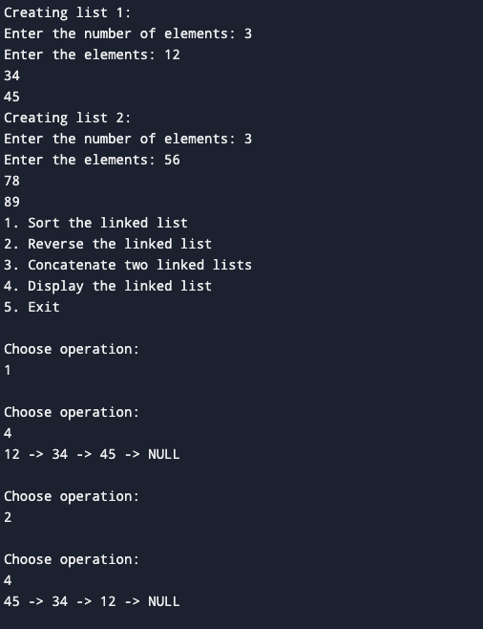

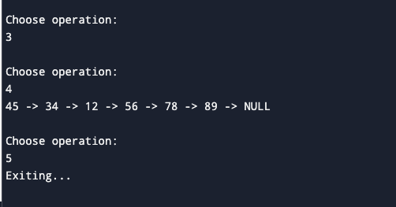

**LAB PROGRAM-6b):**

**WAP to Implement Single Link List to simulate Stack & Queue Operations.**

#include <stdio.h>

#include <stdlib.h>

// Node structure

struct Node {

int data;

struct Node* next;

};

typedef struct Node Node;

// Function to create a new node

Node* createNode(int data) {

Node* newNode = (Node*)malloc(sizeof(Node));

if (newNode == NULL) {

printf("Memory allocation failed!\n");

exit(1);

}

newNode->data = data;

newNode->next = NULL;

return newNode;

}

// Stack operations: push and pop

void push(Node** top, int data) {

Node* newNode = createNode(data);

newNode->next = *top;

*top = newNode;

}

int pop(Node** top) {

if (*top == NULL) {

printf("Stack underflow!\n");

exit(1);

}

Node* temp = *top;

int poppedData = temp->data;

*top = (*top)->next;

free(temp);

return poppedData;

}

// Queue operations: enqueue and dequeue

void enqueue(Node** rear, int data) {

Node* newNode = createNode(data);

if (*rear == NULL) {

*rear = newNode;

} else {

(*rear)->next = newNode;

*rear = newNode;

}

}

int dequeue(Node** front) {

if (*front == NULL) {

printf("Queue underflow!\n");

exit(1);

}

Node* temp = *front;

int dequeuedData = temp->data;

*front = (*front)->next;

free(temp);

return dequeuedData;

}

// Display the elements of the stack or queue

void display(Node* head) {

if (head == NULL) {

printf("Empty\n");

return;

}

while (head != NULL) {

printf("%d ", head->data);

head = head->next;

}

printf("\n");

}

int main() {

Node* stackTop = NULL; // Initialize stack top

Node* queueFront = NULL; // Initialize queue front

Node* queueRear = NULL; // Initialize queue rear

int choice, data;

do {

printf("\nChoose operation:\n");

printf("1. Push (Stack)\n");

printf("2. Pop (Stack)\n");

printf("3. Enqueue (Queue)\n");

printf("4. Dequeue (Queue)\n");

printf("5. Display (Stack)\n");

printf("6. Display (Queue)\n");

printf("7. Exit\n");

scanf("%d", &choice);

switch (choice) {

case 1:

printf("Enter data to push: ");

scanf("%d", &data);

push(&stackTop, data);

break;

case 2:

if (stackTop == NULL) {

printf("Stack is empty.\n");

} else {

printf("Popped element: %d\n", pop(&stackTop));

}

break;

case 3:

printf("Enter data to enqueue: ");

scanf("%d", &data);

enqueue(&queueRear, data);

if (queueFront == NULL) {

queueFront = queueRear;

}

break;

case 4:

if (queueFront == NULL) {

printf("Queue is empty.\n");

} else {

printf("Dequeued element: %d\n", dequeue(&queueFront));

}

break;

case 5:

printf("Stack elements: ");

display(stackTop);

break;

case 6:

printf("Queue elements: ");

display(queueFront);

break;

case 7:

printf("Exiting...\n");

break;

default:

printf("Invalid choice. Please enter a valid option.\n");

}

} while (choice != 7);

return 0;

}

**OUTPUT:**

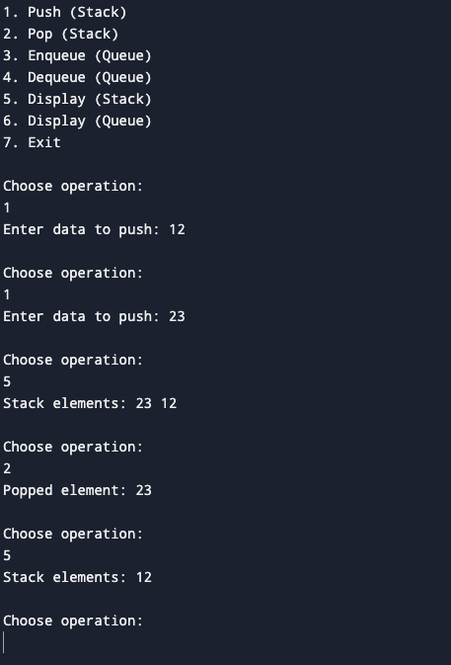

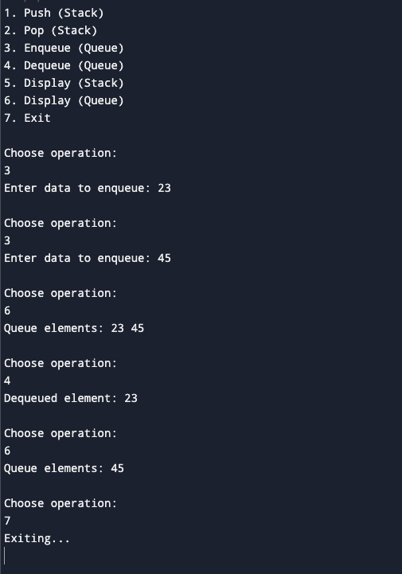

**LEETCODE PROBLEM-1:**

**Score of Parentheses:**

int scoreOfParentheses(char* s) {

int count=0;

int ans=0;

int size=sizeof(s)/sizeof(s[0]);

for(int i=0;s[i]!='\0';i++)

{

if(s[i]=='(')

{

count++;

}

else{

count--;

if(s[i-1]=='(')

{

ans+=pow(2,count);

}

}

}

return ans;

}

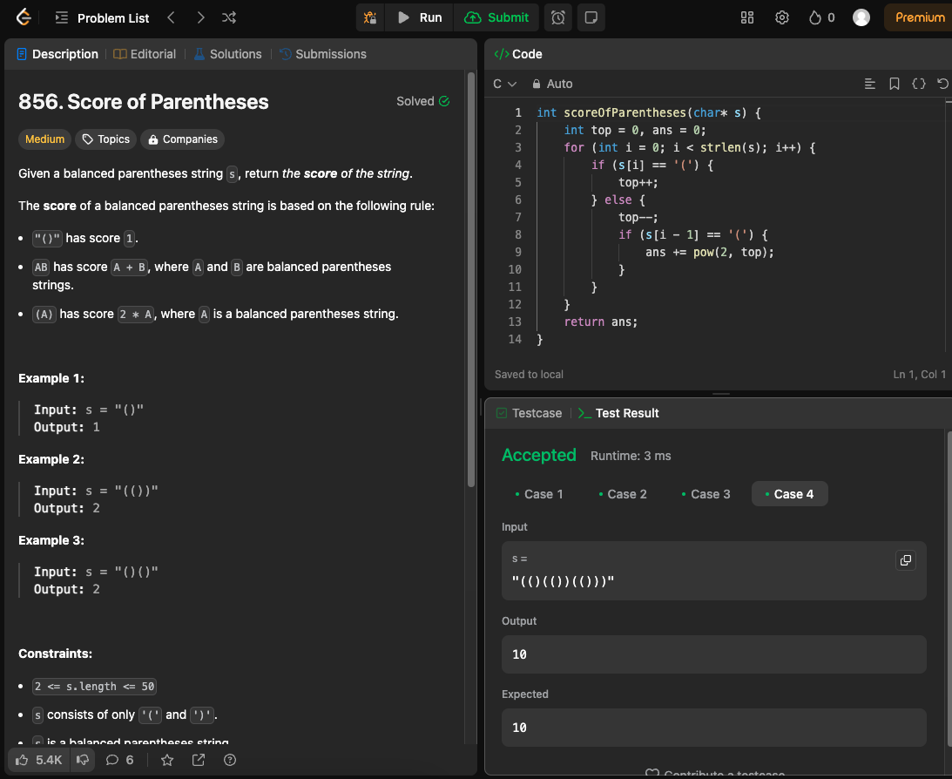

**LAB PROGRAM-7:**

**WAP to Implement doubly link list with primitive operations:**

**a) Create a doubly linked list.**

**b) Insert a new node to the left of the node.**

**c) Delete the node based on a specific value**

**d) Display the contents of the list**

#include <stdio.h>

#include <stdlib.h>

// Node structure

struct Node {

int data;

struct Node* prev;

struct Node* next;

};

typedef struct Node Node;

Node* createNode(int data) {

Node* newNode = (Node*)malloc(sizeof(Node));

if (newNode == NULL) {

printf("Memory allocation failed!\n");

exit(1);

}

newNode->data = data;

newNode->prev = NULL;

newNode->next = NULL;

return newNode;

}

// Function to insert a new node to the left of a specified node

void insertLeft(Node** head, int value, int newValue) {

Node* newNode = createNode(newValue);

Node* current = *head;

while (current != NULL && current->data != value) {

current = current->next;

}

if (current == NULL) {

printf("Node with value %d not found. New node not inserted.\n", value);

free(newNode);

return;

}

newNode->next = current;

newNode->prev = current->prev;

if (current->prev != NULL) {

current->prev->next = newNode;

}

current->prev = newNode;

if (current == *head) {

*head = newNode;

}

}

// Function to delete a node based on a specific value

void deleteNode(Node** head, int value) {

Node* current = *head;

while (current != NULL && current->data != value) {

current = current->next;

}

if (current == NULL) {

printf("Node with value %d not found.\n", value);

return;

}

if (current->prev != NULL) {

current->prev->next = current->next;

}

if (current->next != NULL) {

current->next->prev = current->prev;

}

if (current == *head) {

*head = current->next;

}

free(current);

}

// Function to display the contents of the list

void display(Node* head) {

if (head == NULL) {

printf("List is empty.\n");

return;

}

while (head != NULL) {

printf("%d <-> ", head->data);

head = head->next;

}

printf("NULL\n");

}

int main() {

Node* head = createNode(1);

head->next = createNode(2);

head->next->prev = head;

head->next->next = createNode(3);

head->next->next->prev = head->next;

int choice, value, newValue;

do {

printf("\nChoose operation:\n");

printf("1. Insert a new node to the left of a specified node\n");

printf("2. Delete a node based on a specific value\n");

printf("3. Display the contents of the list\n");

printf("4. Exit\n");

scanf("%d", &choice);

switch (choice) {

case 1:

printf("Enter the value of the existing node: ");

scanf("%d", &value);

printf("Enter the value of the new node: ");

scanf("%d", &newValue);

insertLeft(&head, value, newValue);

break;

case 2:

printf("Enter the value of the node to delete: ");

scanf("%d", &value);

deleteNode(&head, value);

break;

case 3:

printf("List contents:\n");

display(head);

break;

case 4:

printf("Exiting...\n");

break;

default:

printf("Invalid choice. Please enter a valid option.\n");

}

} while (choice != 4);

return 0;

}

**OUTPUT:**

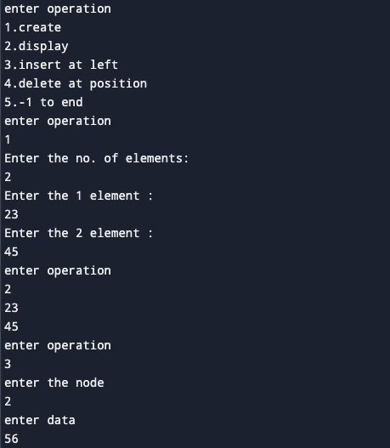

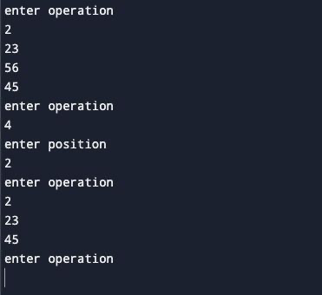

**LEETCODE PROBLEM-2:**

**Delete the Middle Node of the Linked List**

struct node {

int val;

struct node *next;

};

struct node* deleteMiddle(struct node* head) {

if(head==NULL) return NULL;

struct node* newnode=(struct node*)malloc(sizeof(struct node));

newnode->val=0;

newnode->next=head;

struct node* preptr=newnode;

struct node* ptr=head;

while(ptr!=NULL && ptr->next!=NULL){

preptr=preptr->next;

ptr=ptr->next->next;

}

struct node *temp=preptr->next;

preptr->next=preptr->next->next;

free(temp);

struct node* newHead=newnode->next;

free(newnode);

return newHead;

return head;

}

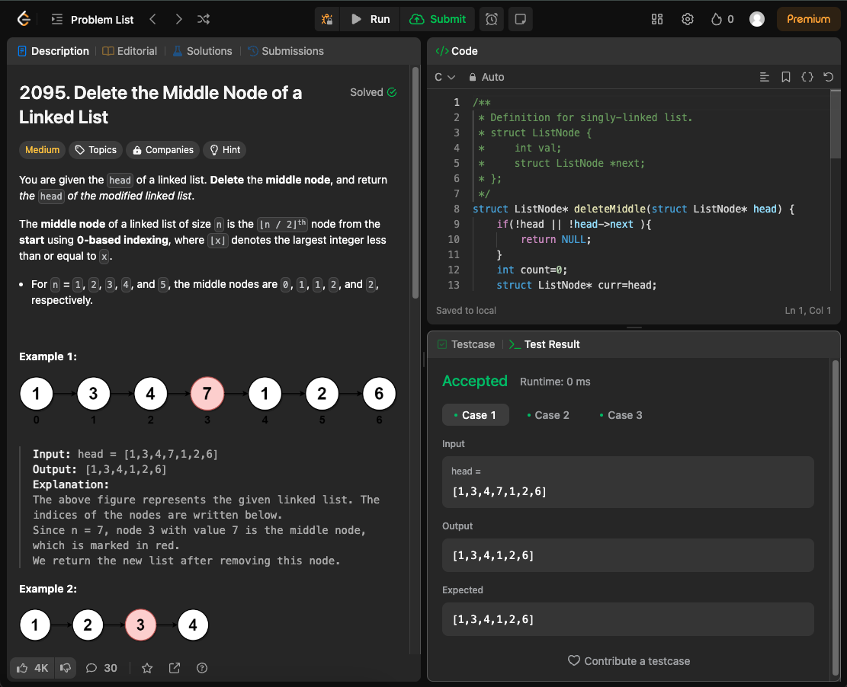

**LAB PROGRAM-8:**

**Write a program**

**a) To construct a binary Search tree.**

**b) To traverse the tree using all the methods i.e., in-order, preorder and post order**

**c) To display the elements in the tree.**

#include <stdio.h>  
#include <stdlib.h>  
  
// Structure for a node of the binary search tree  
struct Node {  
    int data;  
    struct Node* left;  
    struct Node* right;  
};  
  
// Function to create a new node  
struct Node* createNode(int value) {  
    struct Node* newNode = (struct Node*)malloc(sizeof(struct Node));  
    newNode->data = value;  
    newNode->left = newNode->right = NULL;  
    return newNode;  
}  
  
// Function to insert a new node into the binary search tree  
struct Node* insert(struct Node* root, int value) {  
    if (root == NULL) {  
        return createNode(value);  
    }  
     
    if (value < root->data) {  
        root->left = insert(root->left, value);  
    } else if (value > root->data) {  
        root->right = insert(root->right, value);  
    }  
     
    return root;  
}  
  
// Function to traverse the binary search tree using inorder traversal  
void inorderTraversal(struct Node* root) {  
    if (root != NULL) {  
        inorderTraversal(root->left);  
        printf("%d ", root->data);  
        inorderTraversal(root->right);  
    }  
}  
  
// Function to traverse the binary search tree using postorder traversal  
void postorderTraversal(struct Node* root) {  
    if (root != NULL) {  
        postorderTraversal(root->left);  
        postorderTraversal(root->right);  
        printf("%d ", root->data);  
    }  
}  
  
// Function to traverse the binary search tree using preorder traversal  
void preorderTraversal(struct Node* root) {  
    if (root != NULL) {  
        printf("%d ", root->data);  
        preorderTraversal(root->left);  
        preorderTraversal(root->right);  
    }  
}  
  
// Function to display the elements in the binary search tree  
void display(struct Node* root) {  
    printf("Elements in the tree: ");  
    inorderTraversal(root);  
    printf("\n");  
}  
  
int main() {  
    struct Node* root = NULL;  
    int choice, value;  
     
    do {  
        printf("\nBinary Search Tree Operations:\n");  
        printf("1. Insert\n");  
        printf("2. Inorder Traversal\n");  
        printf("3. Postorder Traversal\n");  
        printf("4. Preorder Traversal\n");  
        printf("5. Display\n");  
        printf("6. Exit\n");  
        printf("Enter your choice: ");  
        scanf("%d", &choice);  
         
        switch (choice) {  
            case 1:  
                printf("Enter value to insert: ");  
                scanf("%d", &value);  
                root = insert(root, value);  
                break;  
            case 2:  
                printf("Inorder Traversal: ");  
                inorderTraversal(root);  
                printf("\n");  
                break;  
            case 3:  
                printf("Postorder Traversal: ");  
                postorderTraversal(root);  
                printf("\n");  
                break;  
            case 4:  
                printf("Preorder Traversal: ");  
                preorderTraversal(root);  
                printf("\n");  
                break;  
            case 5:  
                display(root);  
                break;  
            case 6:  
                printf("Exiting...\n");  
                break;  
            default:  
                printf("Invalid choice! Please enter a valid option.\n");  
        }  
    } while (choice != 6);  
     
    return 0;  
}

**OUTPUT:**

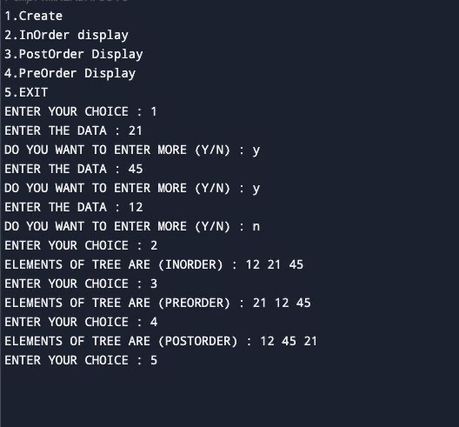

**LEETCODE PROBLEM-4:**

**Delete a node in BST**

struct TreeNode* smallest(struct TreeNode* root)

{

struct TreeNode * cur=root;

while(cur->left!=NULL)

{

cur=cur->left;

}

return cur;

}

struct TreeNode* deleteNode(struct TreeNode* root, int key)

{

// base case

if(root==NULL)

{

return root;

}

if(key < root->val)

{

root->left = deleteNode(root->left,key);

}

else if(key > root->val)

{

root->right=deleteNode(root->right,key);

}

else

{

if (root->left == NULL)

{

struct TreeNode *temp = root->right;

free(root);

return temp;

}

else if (root->right == NULL)

{

struct TreeNode *temp = root->left;

free(root);

return temp;

}

struct TreeNode *temp = smallest(root->right);

root->val = temp->val;

root->right = deleteNode(root->right, root->val);

}

return root;

}

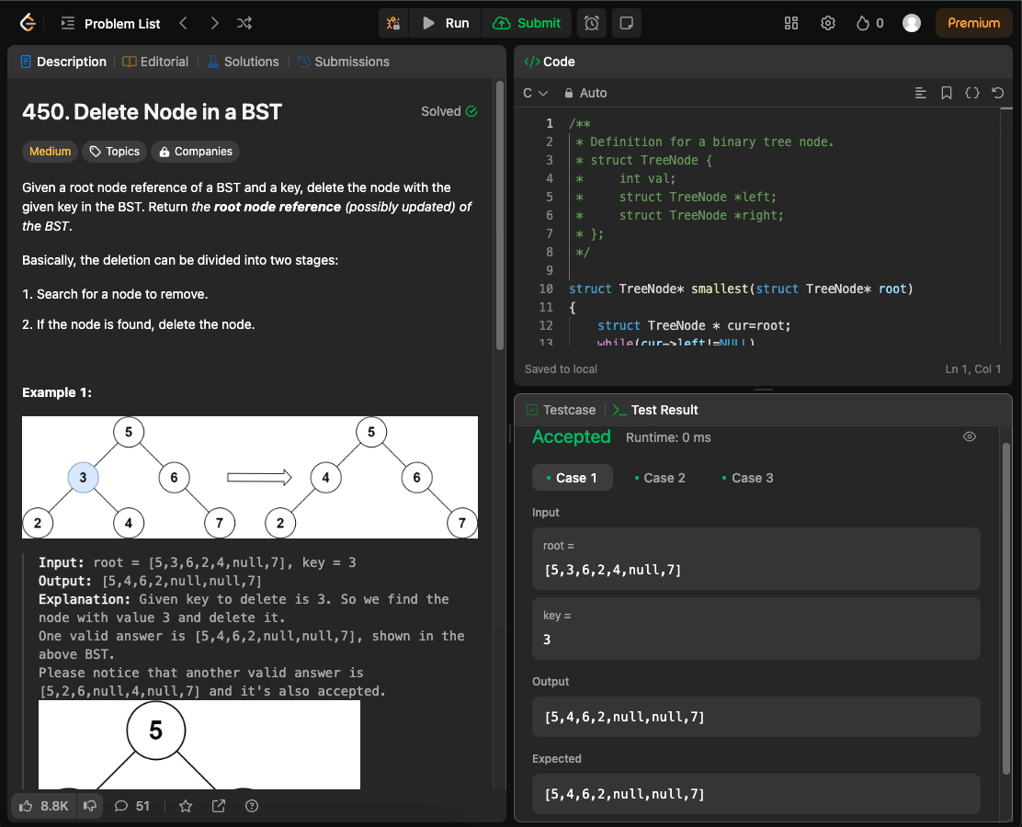

**LEETCODE PROBLEM-5:**

**Find bottom left tree value**

/**

* Definition for a binary tree node.

* struct TreeNode {

* int val;

* struct TreeNode *left;

* struct TreeNode *right;

* };

*/

#define MAX_SIZE 1000

typedef struct {

struct TreeNode* data[MAX_SIZE];

int front;

int rear;

} RingBuffer;

void append(RingBuffer* buffer, struct TreeNode* node) {

if (buffer->front == -1) {

buffer->front = 0;

buffer->rear = 0;

}

else if (buffer->rear == MAX_SIZE - 1) buffer->rear = 0;

else buffer->rear++;

buffer->data[buffer->rear] = node;

}

struct TreeNode* popleft(RingBuffer* buffer) {

struct TreeNode* node = buffer->data[buffer->front];

if (buffer->front == buffer->rear) {

buffer->front = -1;

buffer->rear = -1;

}

else if (buffer->front == MAX_SIZE - 1) buffer->front = 0;

else buffer->front++;

return node;

}

int findBottomLeftValue(struct TreeNode* root) {

if (root == NULL) return -1;

RingBuffer buffer = {

.front = -1,

.rear = -1

};

append(&buffer, root);

struct TreeNode* node;

while( buffer.front != -1 ){

node = popleft(&buffer);

if (node->right) append(&buffer, node->right);

if (node->left) append(&buffer, node->left);

}

return node->val;

}

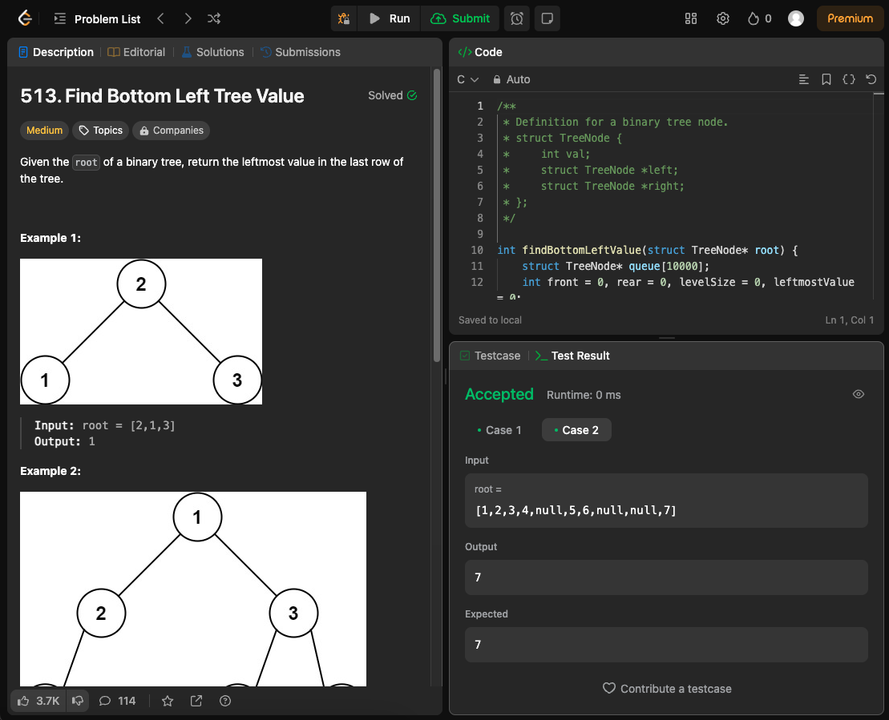

**LAB PROGRAM-9a):**

**Write a program to traverse a graph using BFS method.**

#include <stdio.h>  
#include <stdlib.h>  
  
#define MAX_NODES 100  
  
// Define a structure for a node in the graph  
struct Node {  
    int data;  
    struct Node* next;  
};  
  
// Define a structure for the graph  
struct Graph {  
    int numNodes;  
    struct Node* adjLists[MAX_NODES];  
    int visited[MAX_NODES];  
};  
  
// Function to create a new node  
struct Node* createNode(int data) {  
    struct Node* newNode = (struct Node*)malloc(sizeof(struct Node));  
    newNode->data = data;  
    newNode->next = NULL;  
    return newNode;  
}  
  
// Function to create a graph with n nodes  
struct Graph* createGraph(int n) {  
    struct Graph* graph = (struct Graph*)malloc(sizeof(struct Graph));  
    graph->numNodes = n;  
    for (int i = 0; i < n; i++) {  
        graph->adjLists[i] = NULL;  
        graph->visited[i] = 0;  
    }  
    return graph;  
}  
  
// Function to add an edge to the graph  
void addEdge(struct Graph* graph, int src, int dest) {  
    // Add edge from src to dest  
    struct Node* newNode = createNode(dest);  
    newNode->next = graph->adjLists[src];  
    graph->adjLists[src] = newNode;  
  
    // Add edge from dest to src  
    newNode = createNode(src);  
    newNode->next = graph->adjLists[dest];  
    graph->adjLists[dest] = newNode;  
}  
  
// Function to perform Breadth First Search  
void BFS(struct Graph* graph, int startNode) {  
    // Create a queue for BFS  
    int queue[MAX_NODES];  
    int front = 0, rear = 0;  
  
    // Mark the current node as visited and enqueue it  
    graph->visited[startNode] = 1;  
    queue[rear++] = startNode;  
  
    while (front < rear) {  
        // Dequeue a vertex from queue and print it  
        int current = queue[front++];  
        printf("%d ", current);  
  
        // Get all adjacent vertices of the dequeued vertex current  
        // If an adjacent has not been visited, then mark it visited and enqueue it  
        struct Node* temp = graph->adjLists[current];  
        while (temp) {  
            int adjNode = temp->data;  
            if (!graph->visited[adjNode]) {  
                graph->visited[adjNode] = 1;  
                queue[rear++] = adjNode;  
            }  
            temp = temp->next;  
        }  
    }  
}  
  
int main() {  
    // Get the number of nodes from the user  
    int numNodes;  
    printf("Enter the number of nodes: ");  
    scanf("%d", &numNodes);  
  
    // Create a graph with the specified number of nodes  
    struct Graph* graph = createGraph(numNodes);  
  
    // Get the number of edges from the user  
    int numEdges;  
    printf("Enter the number of edges: ");  
    scanf("%d", &numEdges);  
  
    // Add edges  
    for (int i = 0; i < numEdges; i++) {  
        int src, dest;  
        printf("Enter edge %d (source destination): ", i + 1);  
        scanf("%d %d", &src, &dest);  
        addEdge(graph, src, dest);  
    }  
  
    // Print BFS traversal  
    int startNode;  
    printf("Enter the starting node for BFS traversal: ");  
    scanf("%d", &startNode);  
    printf("BFS traversal starting from node %d: ", startNode);  
    BFS(graph, startNode);  
  
    return 0;  
}

**OUTPUT:**

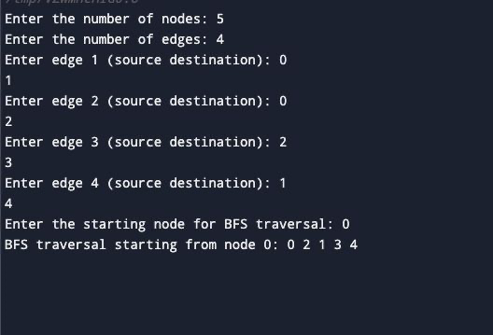

**LAB PROGRAM-9b):**

**Write a program to check whether given graph is connected or not using DFS method**.

#include <stdio.h>  
#include <stdlib.h>  
  
#define MAX_NODES 100  
  
// Define a structure for a node in the graph  
struct Node {  
    int data;  
    struct Node* next;  
};  
  
// Define a structure for the graph  
struct Graph {  
    int numNodes;  
    struct Node* adjLists[MAX_NODES];  
    int visited[MAX_NODES];  
};  
  
// Function to create a new node  
struct Node* createNode(int data) {  
    struct Node* newNode = (struct Node*)malloc(sizeof(struct Node));  
    newNode->data = data;  
    newNode->next = NULL;  
    return newNode;  
}  
  
// Function to create a graph with n nodes  
struct Graph* createGraph(int n) {  
    struct Graph* graph = (struct Graph*)malloc(sizeof(struct Graph));  
    graph->numNodes = n;  
    for (int i = 0; i < n; i++) {  
        graph->adjLists[i] = NULL;  
        graph->visited[i] = 0;  
    }  
    return graph;  
}  
  
// Function to add an edge to the graph  
void addEdge(struct Graph* graph, int src, int dest) {  
    // Add edge from src to dest  
    struct Node* newNode = createNode(dest);  
    newNode->next = graph->adjLists[src];  
    graph->adjLists[src] = newNode;  
  
    // Add edge from dest to src  
    newNode = createNode(src);  
    newNode->next = graph->adjLists[dest];  
    graph->adjLists[dest] = newNode;  
}  
  
// Function to perform Depth First Search  
void DFS(struct Graph* graph, int startNode) {  
    // Mark the current node as visited  
    graph->visited[startNode] = 1;  
    printf("%d ", startNode);  
  
    // Get all adjacent vertices of the current node  
    struct Node* temp = graph->adjLists[startNode];  
    while (temp) {  
        int adjNode = temp->data;  
        if (!graph->visited[adjNode]) {  
            DFS(graph, adjNode);  
        }  
        temp = temp->next;  
    }  
}  
  
int main() {  
    // Get the number of nodes from the user  
    int numNodes;  
    printf("Enter the number of nodes: ");  
    scanf("%d", &numNodes);  
  
    // Create a graph with the specified number of nodes  
    struct Graph* graph = createGraph(numNodes);  
  
    // Get the number of edges from the user  
    int numEdges;  
    printf("Enter the number of edges: ");  
    scanf("%d", &numEdges);  
  
    // Add edges  
    for (int i = 0; i < numEdges; i++) {  
        int src, dest;  
        printf("Enter edge %d (source destination): ", i + 1);  
        scanf("%d %d", &src, &dest);  
        addEdge(graph, src, dest);  
    }  
  
    // Print DFS traversal  
    int startNode;  
    printf("Enter the starting node for DFS traversal: ");  
    scanf("%d", &startNode);  
    printf("DFS traversal starting from node %d: ", startNode);  
    DFS(graph, startNode);  
  
    return 0;  
}

**OUTPUT:**

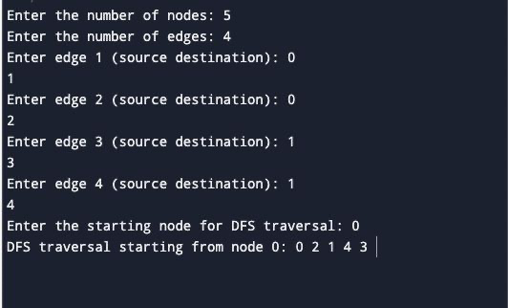

**LAB PROGRAM-10:**

**Given a File of N employee records with a set K of Keys(4-digit) which uniquely determine the records in file F.**

**Assume that file F is maintained in memory by a Hash Table (HT) of m memory locations with L as the set of memory addresses (2-digit) of locations in HT.**

**Let the keys in K and addresses in L are integers.**

**Design and develop a Program in C that uses Hash function H: K -> L as H(K)=K mod m (remainder method), and implement hashing technique to map a given key K to the address space L.**

**Resolve the collision (if any) using linear probing.**

#include <stdio.h>

#include <stdlib.h>

#define SIZE 10 // Size of the hash table

// Employee structure

struct Employee {

int key; // 4-digit key

int data; // Data associated with the employee

};

typedef struct Employee Employee;

// Hash table structure

struct HashTable {

Employee* table[SIZE];

};

typedef struct HashTable HashTable;

// Function to initialize the hash table

void initializeHashTable(HashTable* ht) {

for (int i = 0; i < SIZE; i++) {

ht->table[i] = NULL;

}

}

// Hash function: H(K) = K mod m (remainder method)

int hashFunction(int key) {

return key % SIZE;

}

// Function to insert a record into the hash table

void insert(HashTable* ht, int key, int data) {

int index = hashFunction(key);

while (ht->table[index] != NULL) {

index = (index + 1) % SIZE; // Linear probing

}

Employee* newEmployee = (Employee*)malloc(sizeof(Employee));

newEmployee->key = key;

newEmployee->data = data;

ht->table[index] = newEmployee;

}

// Function to display the contents of the hash table

void displayHashTable(HashTable* ht) {

printf("Hash Table Contents:\n");

printf("Index\tKey\tData\n");

for (int i = 0; i < SIZE; i++) {

if (ht->table[i] != NULL) {

printf("%d\t%d\t%d\n", i, ht->table[i]->key, ht->table[i]->data);

} else {

printf("%d\tEmpty\n", i);

}

}

}

int main() {

HashTable ht;

initializeHashTable(&ht);

int key, data;

char choice;

do {

printf("Enter employee key (4-digit): ");

scanf("%d", &key);

printf("Enter employee data: ");

scanf("%d", &data);

insert(&ht, key, data);

printf("Do you want to enter another employee record? (y/n): ");

scanf(" %c", &choice);

} while (choice == 'y' || choice == 'Y');

// Displaying the contents of the hash table

displayHashTable(&ht);

return 0;

}

**OUTPUT:**

